Spy on Squirrels
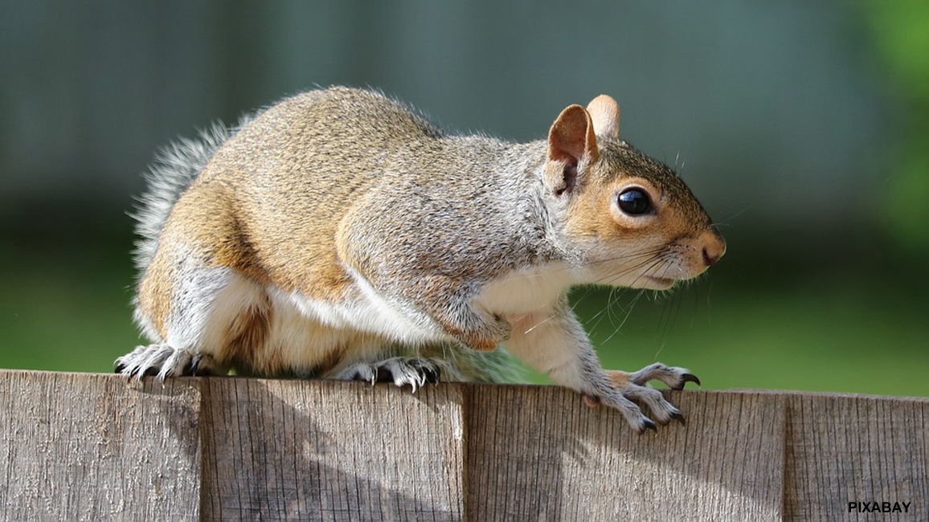

With their bushy tails, bright eyes, and busy-busy-busy ways, squirrels are easy to spot and fun to study.
by Kate Hofmann
Surely you’ve seen plenty of squirrels. They’re busy in front yards, backyards, schoolyards, and pretty much anywhere else you might go. Squirrels scamper and scurry, gather and bury, chase and chatter—all day long.
Are you feeling a little squirrelly? Grab a notebook and start a squirrel study. Stake out a spot in your yard. Pretty soon, you’ll be an expert squirrel-watching expert!


Can you spot the following tree squirrel behaviors? Check off each one you see.
- Clever Climbing. Squirrels are treetop acrobats. With gripping feet and long tails for balance, they climb high and leap along from branch to branch.

- Chasing and Racing. In late winter, squirrels choose mates. Males chase females and try to chase away other males. Watch for them running and leaping at top speed.

- Busy Building. Squirrels make leafy nests in tree holes and on branches. If you spot what seems to be a messy pile of leaves up in a tree, it’s likely a squirrel nest, called a drey (DRAY ).

- Zigging and Zagging. Have you seen a squirrel run out into the road in front of a car, stop, run back, run forward again, and barely escape? This routine seems foolish, but it’s a trick that works well when an animal is chasing the squirrel—just not so well when the “predator” is a car.

- Treasure-Seeking. Acorns and other nuts are favorite foods for squirrels. They stash nuts in trees and bury them in the ground. Then, in winter when food is scarce, they use their sharp noses to sniff out the hidden snacks.

- Daring Dining. You may have seen squirrels trying all kinds of tricks to get to a bird feeder or other yummy food. They don’t give up easily, do they?

- Chatterboxing. Squirrels chatter, click, and squeak to talk to each other. They also may flick their tails. What they’re usually saying is, “Stay away. This food is mine.”
Squirrel antics will make you smile. Scamper outside and see what those busy bushy-tails are up to!
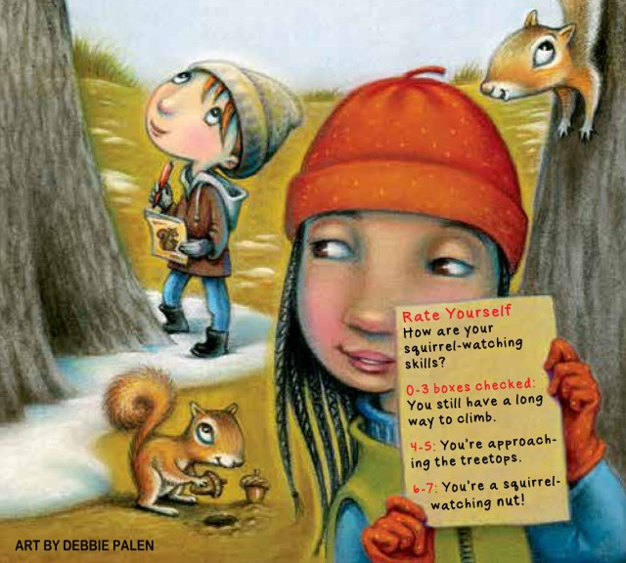

How many squirrel behaviors did you spot??

0-3 You have a long way to climb
4-5 You’re approaching the treetops.
6-7 You’re a squirrel-watching nut!!

